**SATGURU RAM SINGH POLYTECHNIC COLLEGE FOR GIRLS LUDHIANA**



Six Week Training Report Of Minor Project

On

**HEART DISEASE PREDICTOR**

Submitted by:

Ridhimaa Thakur

Class =CSE 5th sem

Roll no= 190319503564

Submitted to:

Mr. Manoj Kumar Jambla

Mrs. Kanika Sharma

Miss. Sharandeep Kaur

(computer science &Engineering)

**CONTENT**

|  |  |  |
| --- | --- | --- |
| ***s.no*** | ***topic*** | ***page*** |
| ***1.*** | ***Acknowledgement*** | ***3*** |
| ***2.*** | ***preface*** | ***4*** |
| ***3.*** | ***Company profile*** | ***5*** |
| ***4.*** | ***Python in Healthcare*** | ***6*** |
| ***5.*** | ***Working in Jupyter Notebook*** | ***7-14*** |
| ***6.*** | ***Files Under Project*** | ***15*** |
| ***7.*** | ***App.py*** | ***16*** |
| ***8.*** | ***Html code*** | ***17-20*** |
| ***9.*** | ***procfile*** | ***21*** |
| ***10.*** | ***Requirements.txt*** | ***22*** |
| ***11.*** | ***tempCodeRunnerFile.py*** | ***23*** |
| ***12.*** | ***GitHub*** | ***24*** |
| ***13.*** | ***Heroku*** | ***25*** |
| ***14.*** | ***Deployed App*** | ***26*** |
| ***15.*** | ***Look Of App*** | ***27*** |
| ***16.*** | ***Working Of App*** | ***28-29*** |
| ***17.*** | ***Predictive Analytics Features And Benefits*** | ***30*** |
| ***18.*** | ***Future Scope*** | ***30*** |
| ***19.*** | ***Conclusion*** | ***31*** |

**Acknowledgement**

I would like to express my special thanks to my respective teachers who give me the golden opportunity to do this wonderful project on the topic “Heart Disease Prediction”, which also helped me in doing a lot of research and I came to know about so many new things I am really thankful to them.

THANK YOU

**Preface**

As a part of Diploma curriculum and in order to gain practical knowledge in the field of Python, Data Science, Machine Learning, I made a report on “HEART DISEASE PREDICTOR”. The basic objective behind doing this report is to get knowledge about different concepts in python and data science.

Doing this project helped me to enhance my knowledge. I joined “Ansh infotech”, for my six weeks training from 27 july 2021 to 11 september 2021.

**Company profile**

*`*

AIT is a leading global IT services, consulting and business solutions provider company that helps global enterprises re-imagine and transform their businesses through Digital technology transformation. The Company harness the power of web development, mobile application development, robotics, cloud, digital marketing, analytics and emerging technologies to help our clients adapt to the digital world and make them successful.

**PYTHON IN HEALTHCARE**

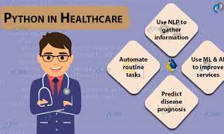

***Predictive Prognosis:***

A common problem that doctors tend to have is providing a proper prognosis for a patient’s disease. A prognosis is an estimation of the progress of a certain disease in a patient. Some might say that this is guesswork by a doctor with limited information and resources, which can be improved.

This is where Python can come in handy and help again, through the use of machine learning. More specifically, deep neural network algorithms are used in predicting the mortality of patients. In most cases of prognosis, doctors rely on a certain biomarker level to make some guess of the prognosis. With the use of the predictive analytics Python can provide, the prognosis of a patient can be estimated easily. Of course, this is used in combination with a doctor’s knowledge and expertise. When a doctor leverages such technology, more accurate prognoses can be made, improving the overall patient experience.

**WORKING IN JUPYTER NOTEBOOK**

**DataSet:** http://www.kaggle.com/ronitf/heart-disease-uci

# *Step 1: Import libraries*

**import** numpy **as** np

**import** pandas **as** pd

**import** matplotlib.pyplot **as** plt

**import** seaborn **as** sns

**%matplotlib** inline

***Step 2:*** *Data Analysis*

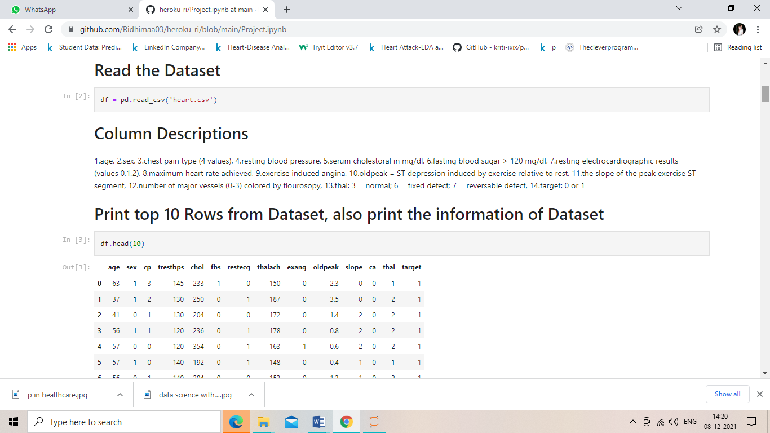

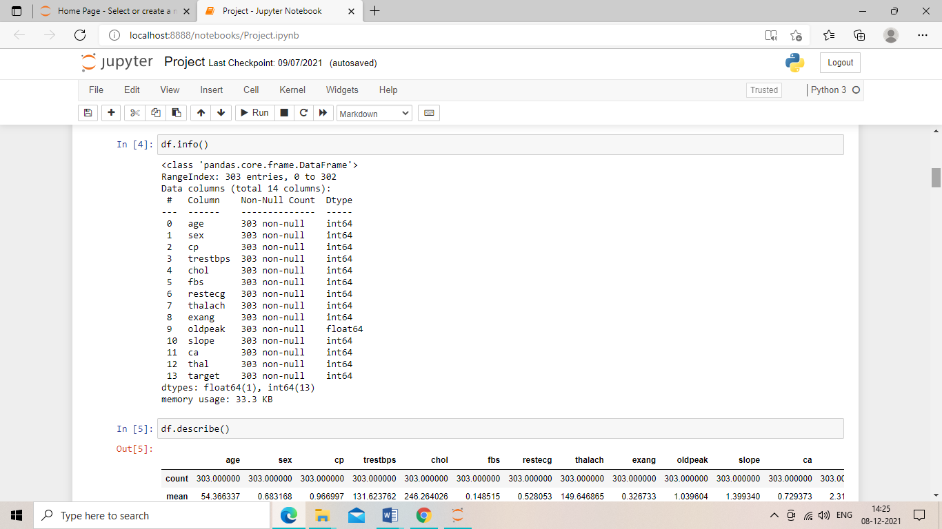

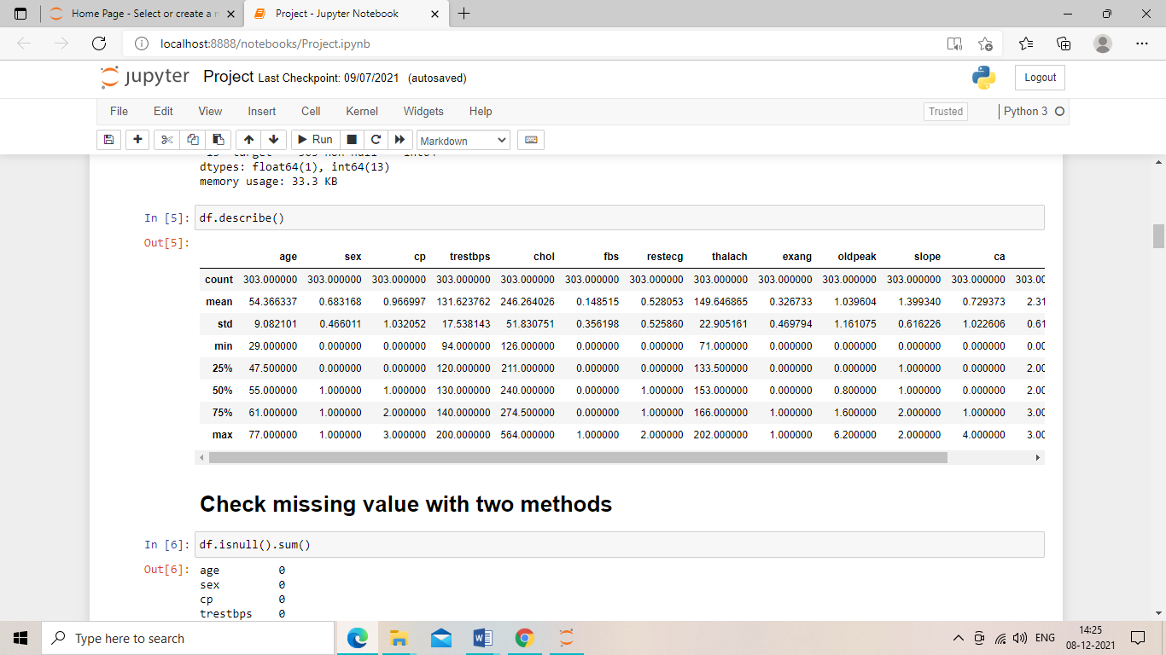

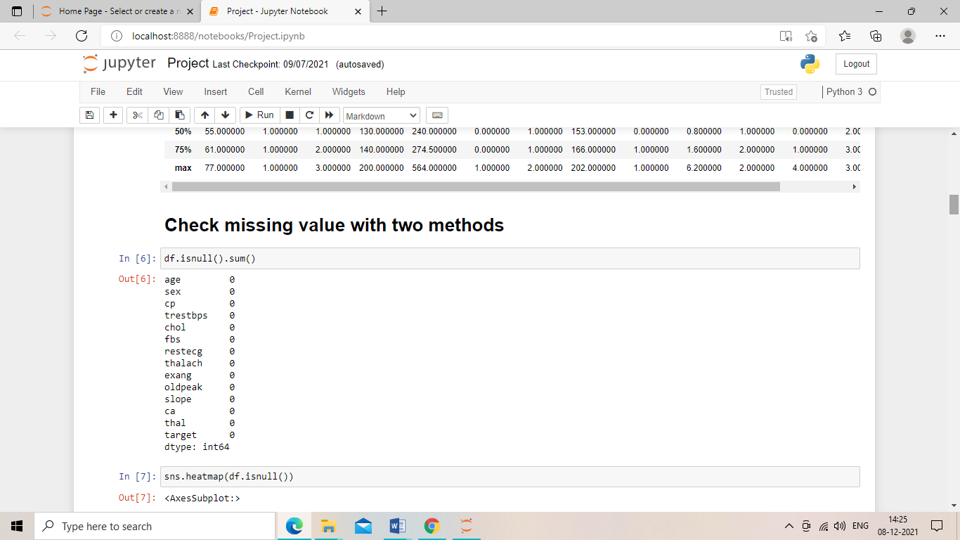

***Step 3:*** *checking whether the data is clean or not with heat map. 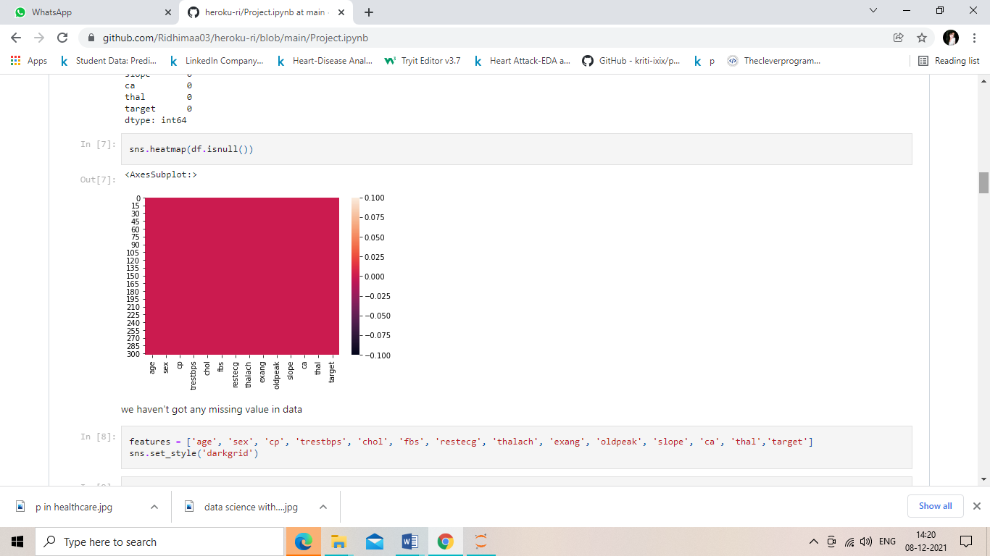*

***Step 4:*** *Data Visualization*

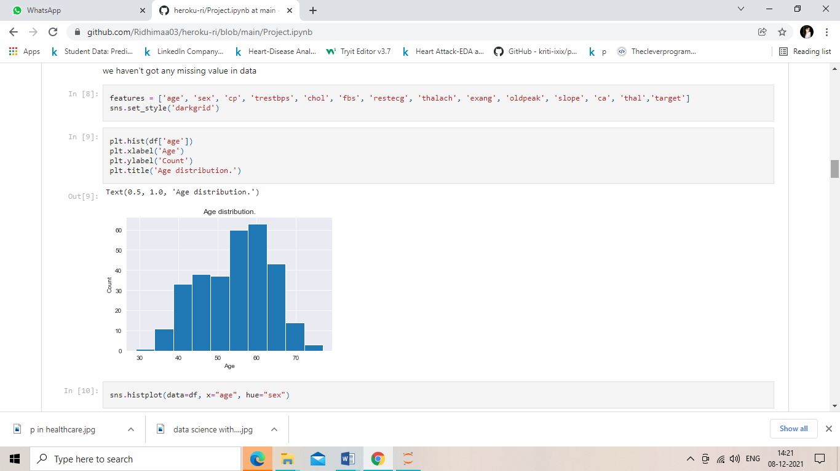

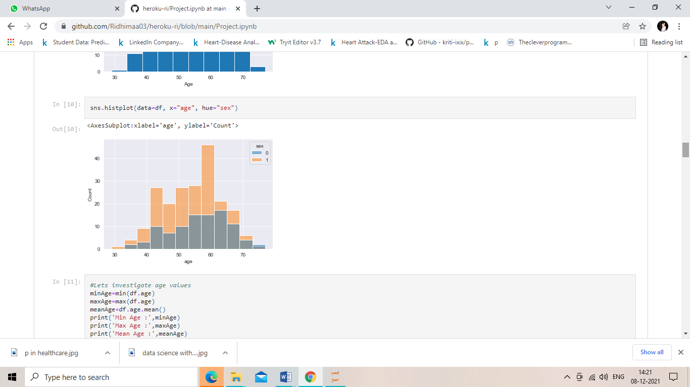

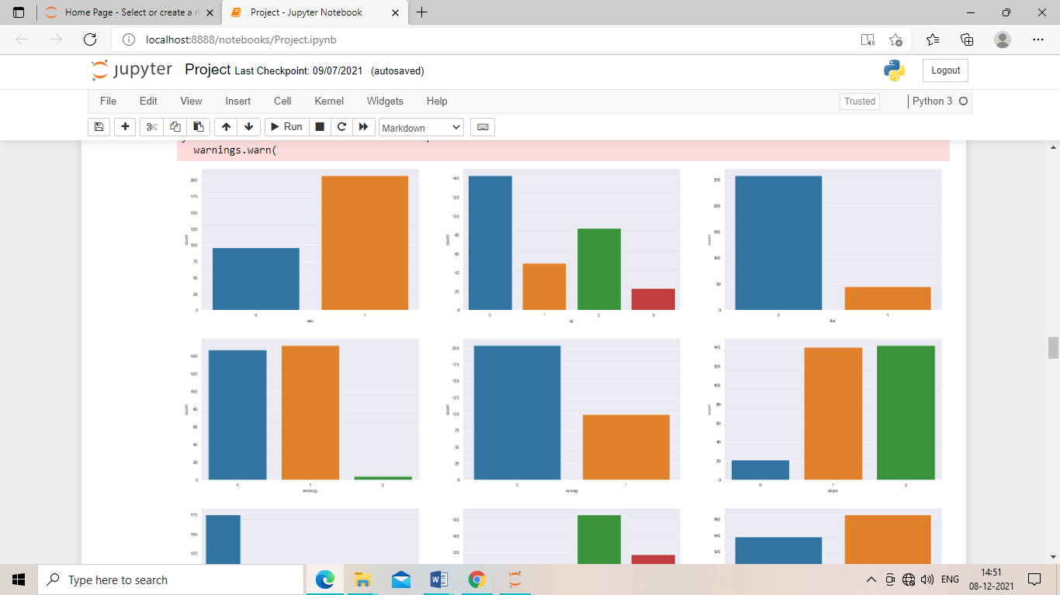

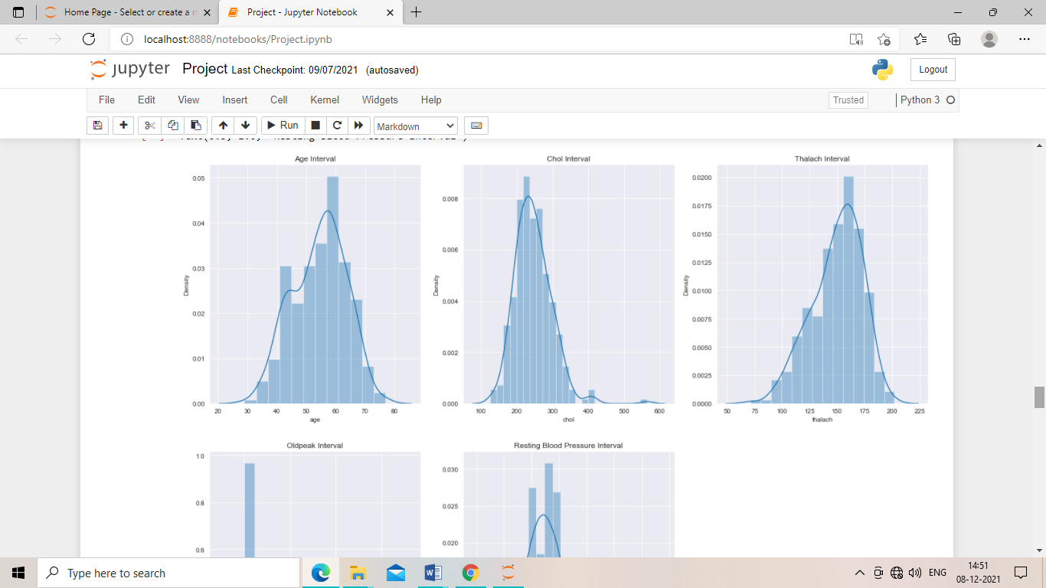

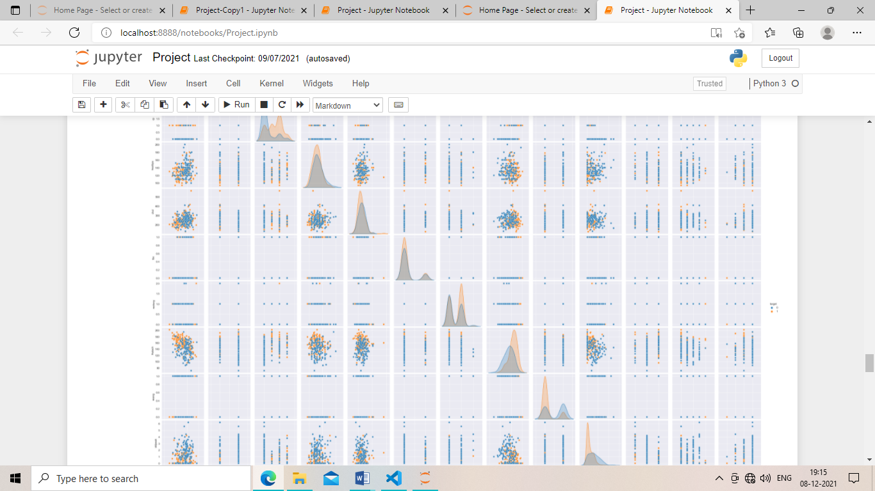

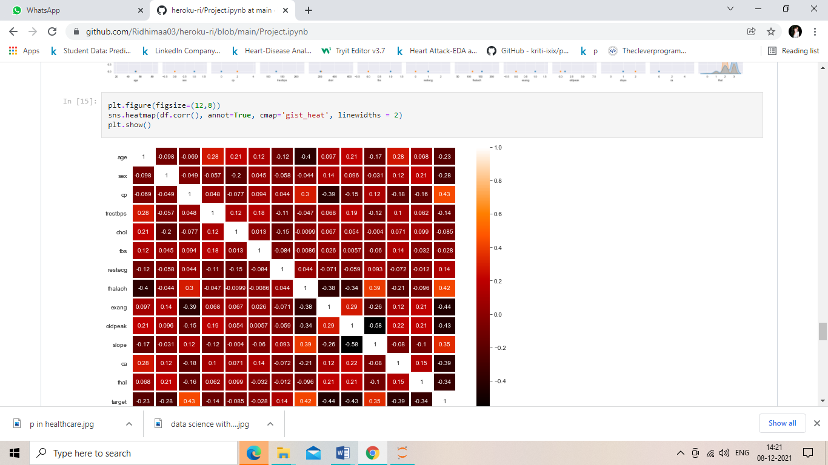

***Step 5:*** *Training the model*

from sklearn.model_selection import train_test_split

y = df["target"]

X = df.drop('target',axis=1)

X_train, X_test, y_train, y_test = train_test_split(X, y, test_size=0.20, random_state = 0)

from sklearn.linear_model import LogisticRegression

from sklearn.metrics import confusion_matrix, accuracy_score

from sklearn.metrics import precision_score, recall_score, f1_score

from sklearn.metrics import classification_report

model_lgr = 'Logistic Regression'

lr = LogisticRegression()

model = lr.fit(X_train, y_train)

lr_predict=lr.predict(X_test)

lr_acc_score = accuracy_score(y_test, lr_predict)

***CONFUSION MATRIX***

print("confussion matrix")

print(lr_conf_matrix)

print("-------------------------------------------")

print("Accuracy of Logistic Regression:",lr_acc_score*100,'\n')

print("-------------------------------------------")

print(classification_report(y_test,lr_predict))

confussion matrix

[[22 5]

[ 4 30]]

-------------------------------------------

Accuracy of Logistic Regression: 85.24590163934425

-------------------------------------------

precision recall f1-score support

0 0.85 0.81 0.83 27

1 0.86 0.88 0.87 34

accuracy 0.85 61

macro avg 0.85 0.85 0.85 61

weighted avg 0.85 0.85 0.85 61

# Pickle our model

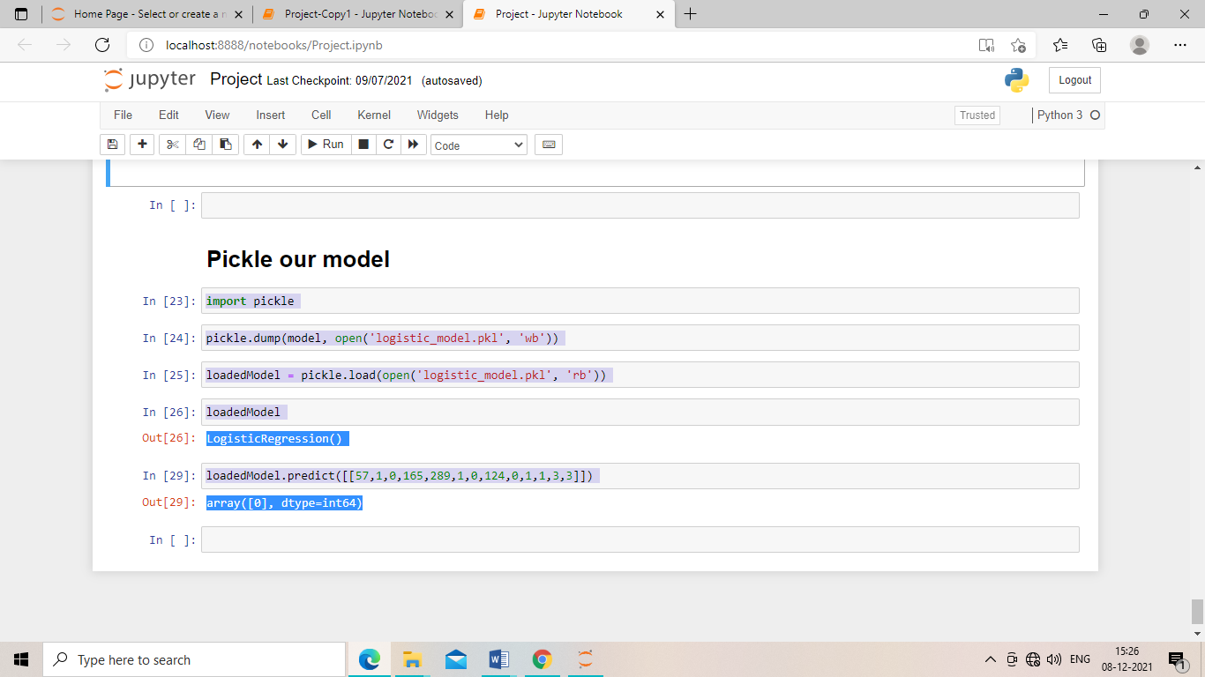

***FILES UNDER PROJECT***

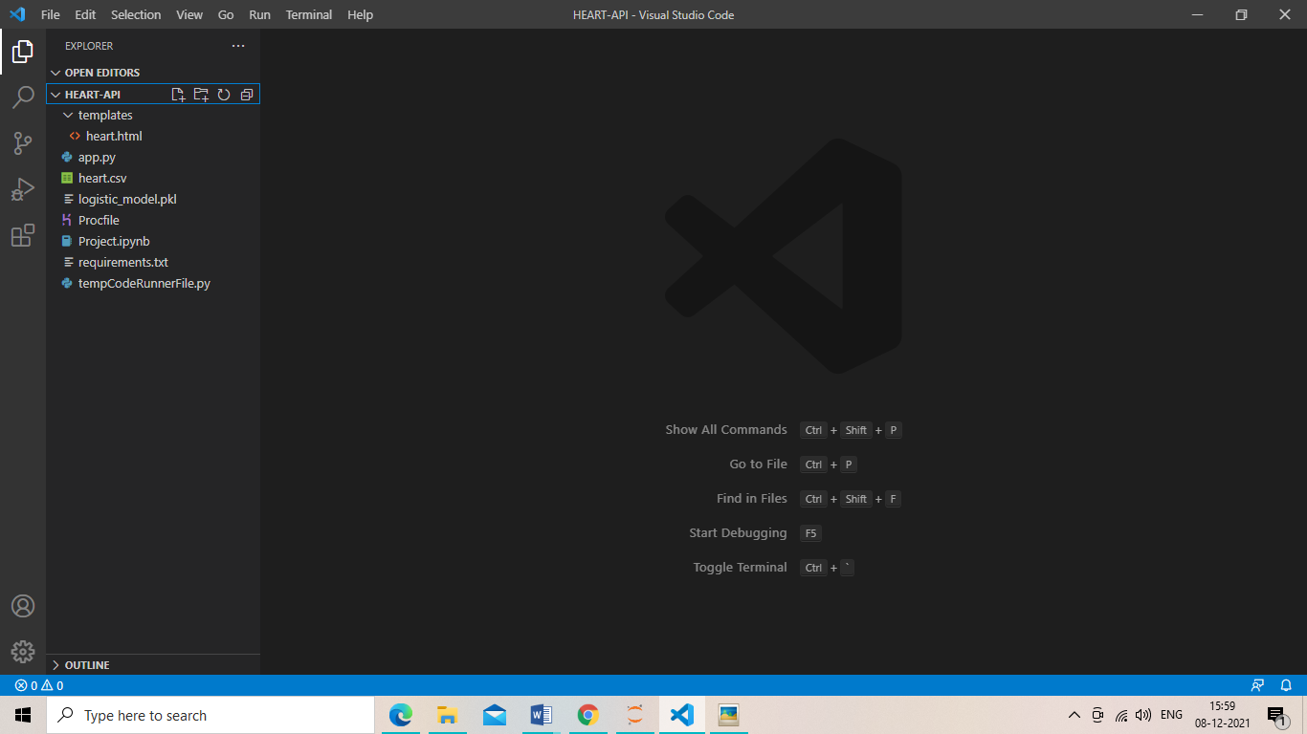

**App.py**

#Importing the libraries

import pickle

from flask import Flask, render_template, request

#Global variables

app = Flask(__name__)

loadedModel = pickle.load(open('logistic_model.pkl', 'rb'))

#www.google.co.in/prediction

#Routes

@app.route('/')

def home():

    return render_template('heart.html')

@app.route('/prediction', methods=['POST'])

def prediction():

    age = int(request.form['age'])

    sex = int(request.form['sex'])

    cp= int(request.form['cp'])

    trestbps= int(request.form['trestbps'])

    chol = int(request.form['chol'])

    fbs = int(request.form['fbs'])

    restecg= int(request.form['restecg'])

    thalach = int(request.form['thalach'])

    exang = int(request.form['exang'])

    oldpeak = int(request.form['oldpeak'])

    slope = int(request.form['slope'])

    ca = int(request.form['ca'])

    thal = int(request.form['thal'])

    Diagnosis = loadedModel.predict([[age,sex,cp,trestbps,chol,fbs,restecg,thalach,exang,oldpeak,slope,ca,thal]])[0]

    if Diagnosis == 0:

        Diagnosis = "No presence of heart disease"

    else:

        Diagnosis = "Presence of heart disease"

    return render_template('heart.html', output=Diagnosis)

#Main function

if __name__ == '__main__':

    app.run(debug=True)

***Html Code***

<!DOCTYPE html>

<html>

<head>

    <title>Heart disease Prediction</title>

<meta charset="utf-8">

<meta name="viewport" content="width=device-width, initial-scale=1">

<link rel="stylesheet" href="https://maxcdn.bootstrapcdn.com/bootstrap/3.4.1/css/bootstrap.min.css">

<script src="https://ajax.googleapis.com/ajax/libs/jquery/3.5.1/jquery.min.js"></script>

<script src="https://maxcdn.bootstrapcdn.com/bootstrap/3.4.1/js/bootstrap.min.js"></script>

<style type="text/css">

    .btn{

        background: linear-gradient(to bottom right, #28015c, #33ccff);

        color: white;

    }

    .fform{

        background-color: #eee;

        padding: 40px;

        margin-top: 60px;

        margin-bottom: 40px;

    }

    .heading{

        background-color: #28015c;

        padding: 8px;

        color: white;

        text-align: center;

    }

    .top {

        position: relative;

        margin-top:35px;

    }

    body {

        background: url('https://images.unsplash.com/photo-1623134915831-9dcb66cf9a8e?ixid=MnwxMjA3fDB8MHxwaG90by1wYWdlfHx8fGVufDB8fHx8&ixlib=rb-1.2.1&auto=format&fit=crop&w=1600&q=80');

        background-size: cover;

    }

</style>

</head>

<body style="background-repeat: no-repeat; background-size: 100% 100%; background-attachment: fixed;">

    <div class="col-lg-12">

        <div class="container" >

            <h1 class="col-lg-6 " style="margin-top: 10%; ">Heart disease Prediction</h1>

            <div class="col-lg-6 ">

                <div class="col-lg-12 heading">

                    <h3><b>Enter Heart Details</b></h3>

                </div>

                <form class="form fform" action="http://127.0.0.1:5000/prediction" method="post">

                    <div class="form-group">

                        <input type="number" name="age" placeholder="Enter age" class="form-control">

                    </div>

                    <div class="form-group">

                        <input type="number" name="trestbps" placeholder="Enter resting blood pressure range 94-200" class="form-control">

                    </div>

                    <div class="form-group">

                        <input type="number" name="chol" placeholder="Enter cholesterol" class="form-control">

                    </div>

                    <div class="form-group">

                        <input type="number" name="thalach" placeholder="Enter maximum heart rate" class="form-control">

                    </div>

                    <div class="form-group">

                        <input type="number" name="oldpeak" placeholder="Enter ST depression after exercise" class="form-control" steps=0.001 pattern="^\d+(?:\.\d{1,2})?$"  value="0.00">

                    </div>

                    <div class="form-group">

                        <b>Thal: </b> &nbsp;

                        <input type='radio' name='thal' value=1> Normal &nbsp;

                        <input type='radio' name='thal' value=2> Fixed Defect &nbsp;

                        <input type='radio' name='thal' value=3> Reversable Defect

                    </div>

                    <div class="form-group">

                        <b>Blood Sugar: </b> &nbsp;

                        <input type='radio' name='fbs' value=1> > 120 mg/dl &nbsp;

                        <input type='radio' name='fbs' value=0> < 120 mg/dl

                    </div>

                    <div class="form-group">

                        <b>Chest Pain Rating: </b> &nbsp;

                        <input type='radio' name='cp' value=0> 0 &nbsp;

                        <input type='radio' name='cp' value=1> 1 &nbsp;

                        <input type='radio' name='cp' value=2> 2 &nbsp;

                        <input type='radio' name='cp' value=3> 3 &nbsp;

                    </div>

                    <div class="form-group">

                        <b>Exercise Induced Angina: </b> &nbsp;

                        <input type='radio' name='exang' value=1> Yes &nbsp;

                        <input type='radio' name='exang' value=0> No

                    </div>

                    <div class="form-group">

                        <b>Sex: </b> &nbsp;

                        <input type='radio' name='sex' value=1> Male &nbsp;

                        <input type='radio' name='sex' value=2> Female

                    </div>

                    <div class="form-group">

                        <b>Resting ECG: </b> &nbsp;

                        <input type='radio' name='restecg' value=0> 0 &nbsp;

                        <input type='radio' name='restecg' value=1> 1 &nbsp;

                        <input type='radio' name='restecg' value=2> 2

                    </div>

                    <div class="form-group">

                        <b>Slope: </b> &nbsp;

                        <input type='radio' name='slope' value=0> 0 &nbsp;

                        <input type='radio' name='slope' value=1> 1 &nbsp;

                        <input type='radio' name='slope' value=2> 2

                    </div>

                    <div class="form-group">

                        <b>Number of vessels coloured by flourosopy: (0-3)</b><input type='range' name='ca' min=0 max=3>

                    </div>

                    <div class="form-group">

                        <input type="submit" name="submit" value="Submit" class="btn btn-md">

                    </div>

                    <div class="form-group">

                        <b> Diagnosis: {{ output }} </b>

                    </div>

                </form>

            </div>

        </div>

    </div>

</body>

</html>

***Procfile***



*Procfile is a mechanism for declaring what commands are run by your application's dynos on the Heroku platform. From Process Types and the Procfile, which is a good introduction, but basically you use the Procfile to tell Heroku how to run various pieces of your app.*

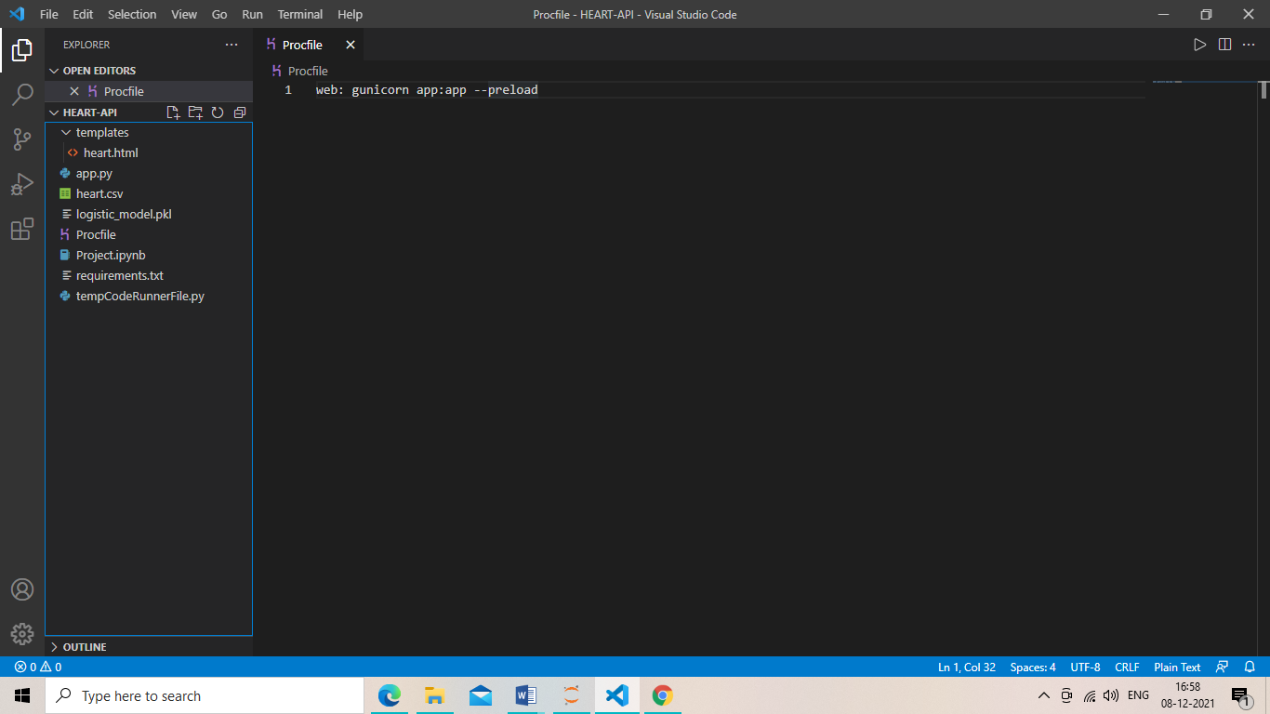

***requirments.txt***

*In Python requirement. txt file is a type of file that usually stores information about all the libraries, modules, and packages in itself that are used while developing a particular project. It also stores all files and packages on which that project is dependent or requires to run. Typically this file "requirement*

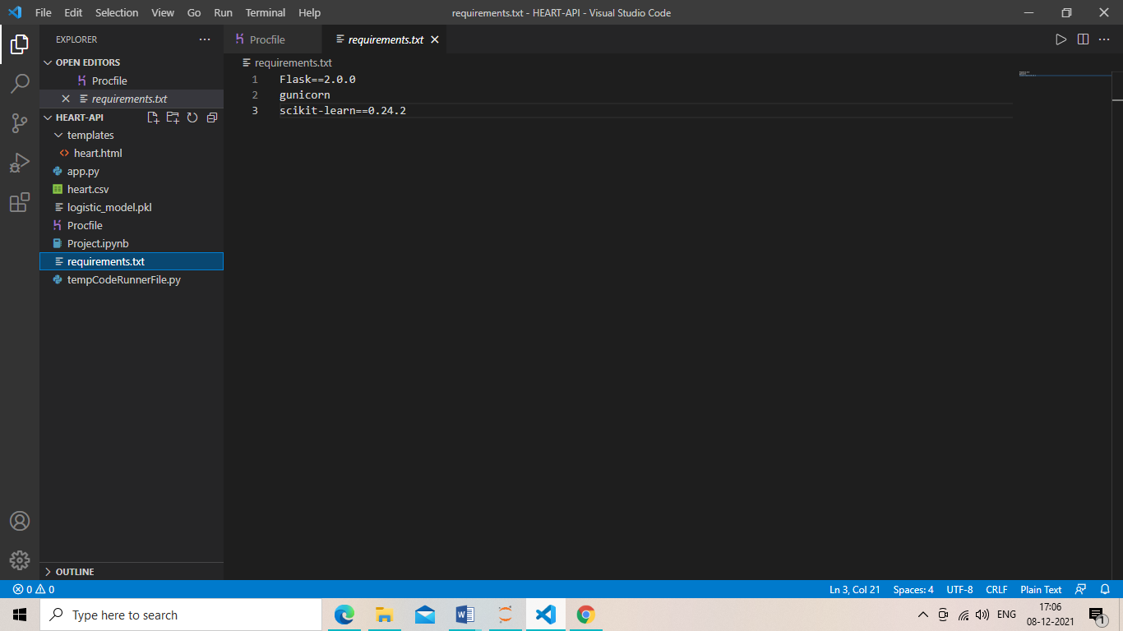

***tempCodeRunnerFile.py***

*This temp file "tempCodeRunnerFile" indicates that you have selected part of the code snippet and run it.*

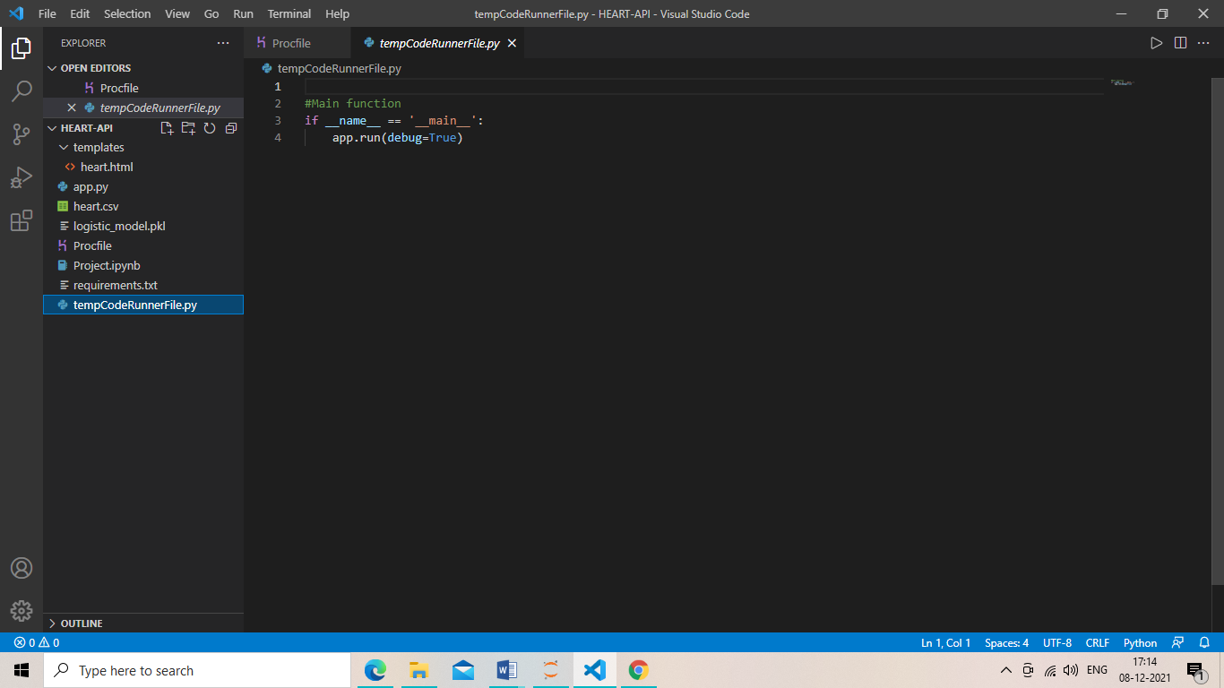

***GitHub***

**

*GitHub, Inc. is a provider of Internet hosting for software development and version control using Git. It offers the distributed version control and source code management (SCM) functionality of Git, plus its own features. It provides access control and several collaboration features such as bug tracking, feature requests, task management, continuous integration and wikis for every project*

***LETS OUR REPOSITORY ON GITHUB***

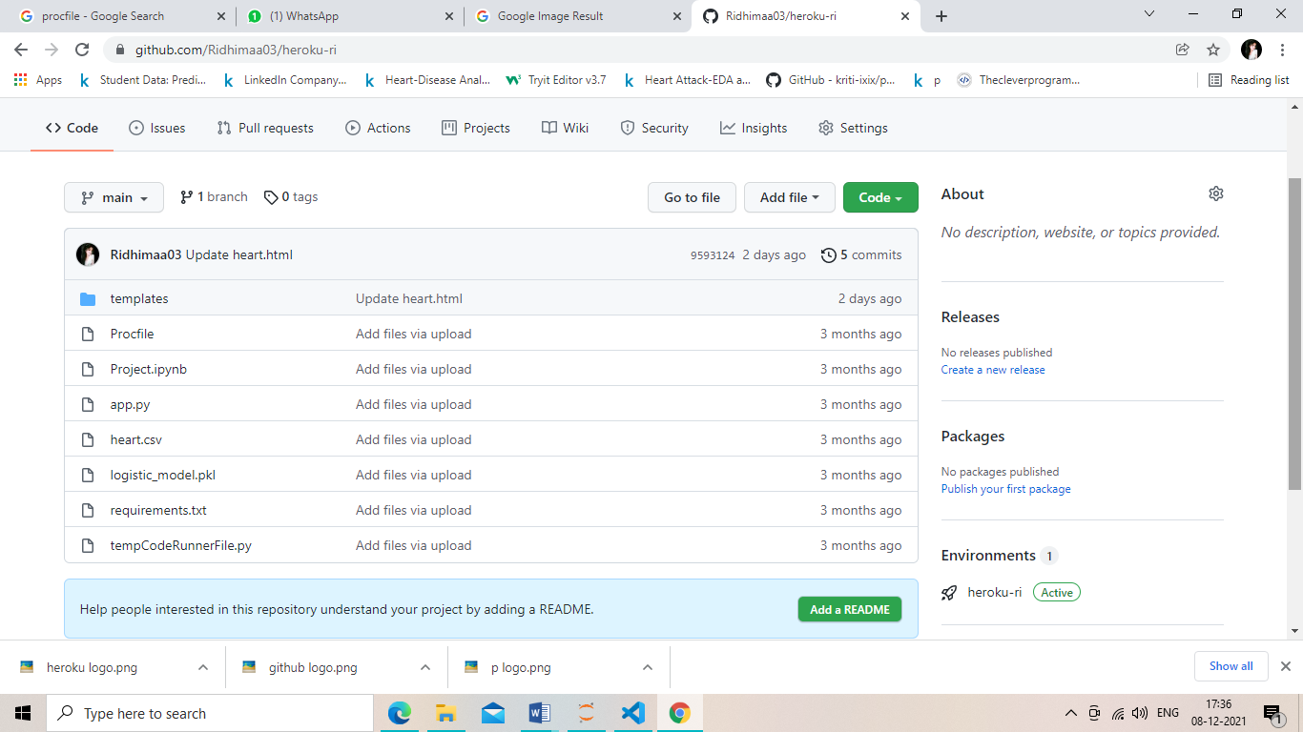

***HEROKU***



*Heroku is a cloud platform as a service (PaaS) supporting several programming languages. One of the first cloud platforms, Heroku has been in development since June 2007, when it supported only the Ruby programming language, but now supports Java, Node.js, Scala, Clojure, Python, PHP, and Go.*

* *We need to connect our github to heroku to deploy our project*

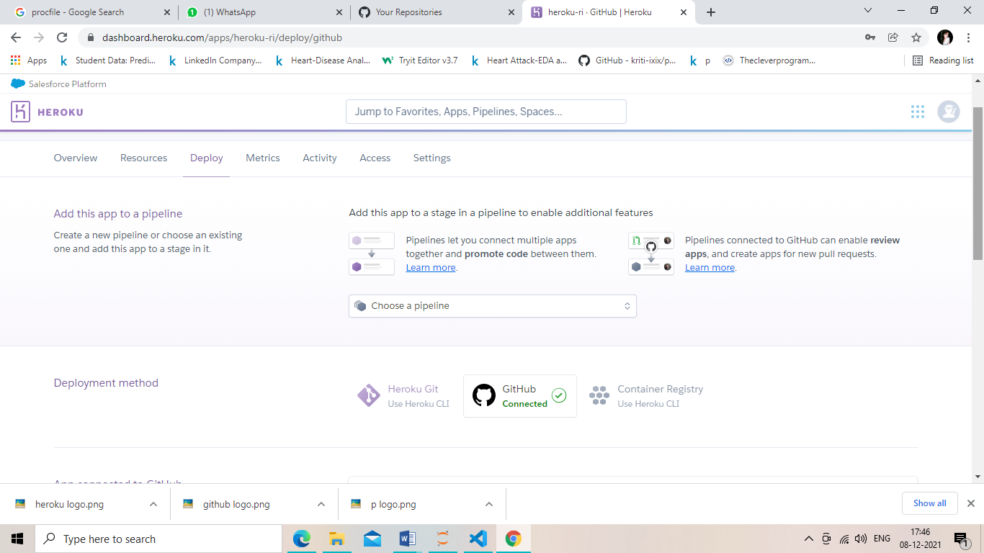

*HERE IS OUR DEPLOYED APP*

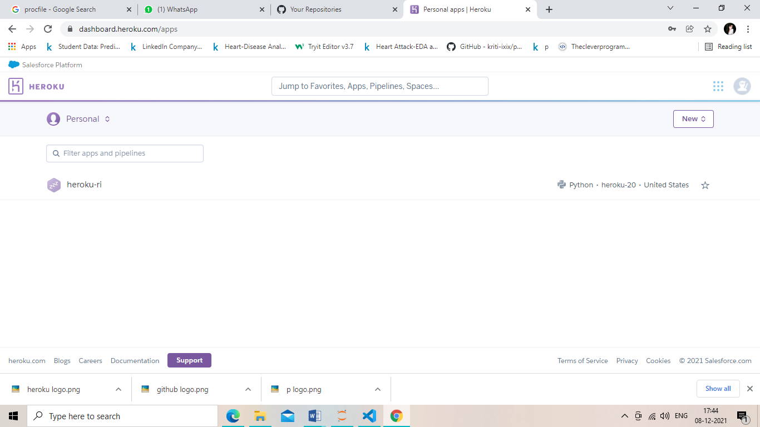

*By clicking on open app we can oper our app as shown below:*

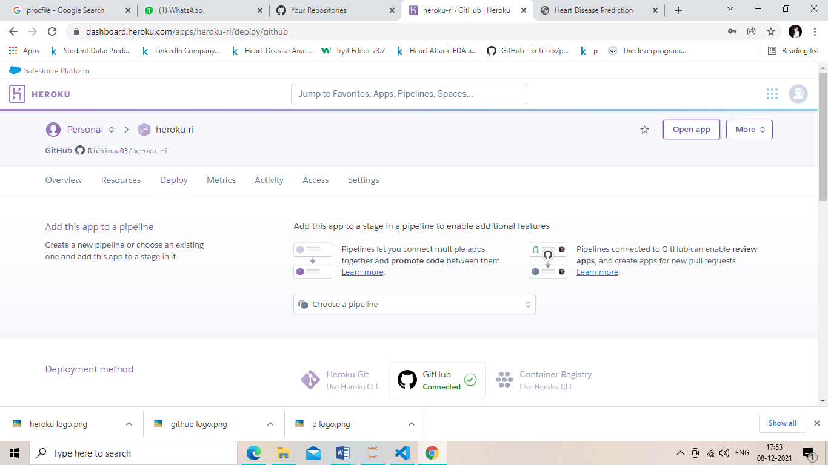

***Look Af App***

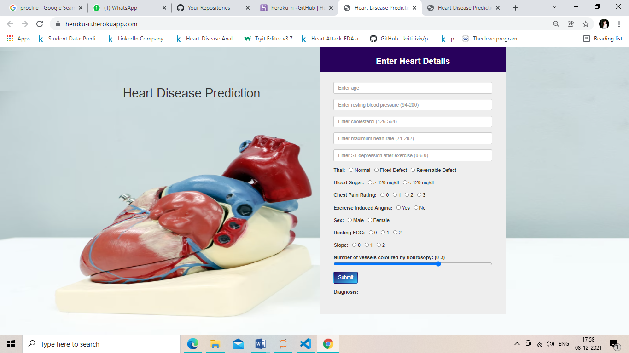

*Link of app:* [*http://heroku-ri.herokuapp.com/*](http://heroku-ri.herokuapp.com/)

***Working Of App***

* *If there is no presence of heart disease*

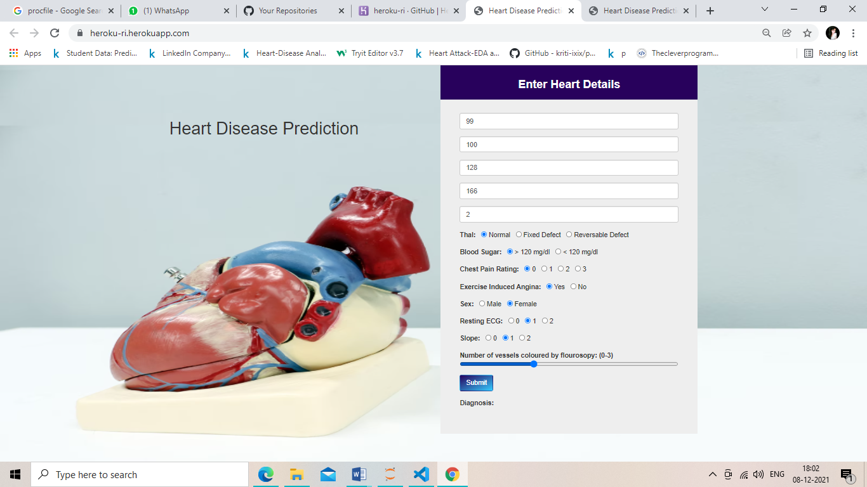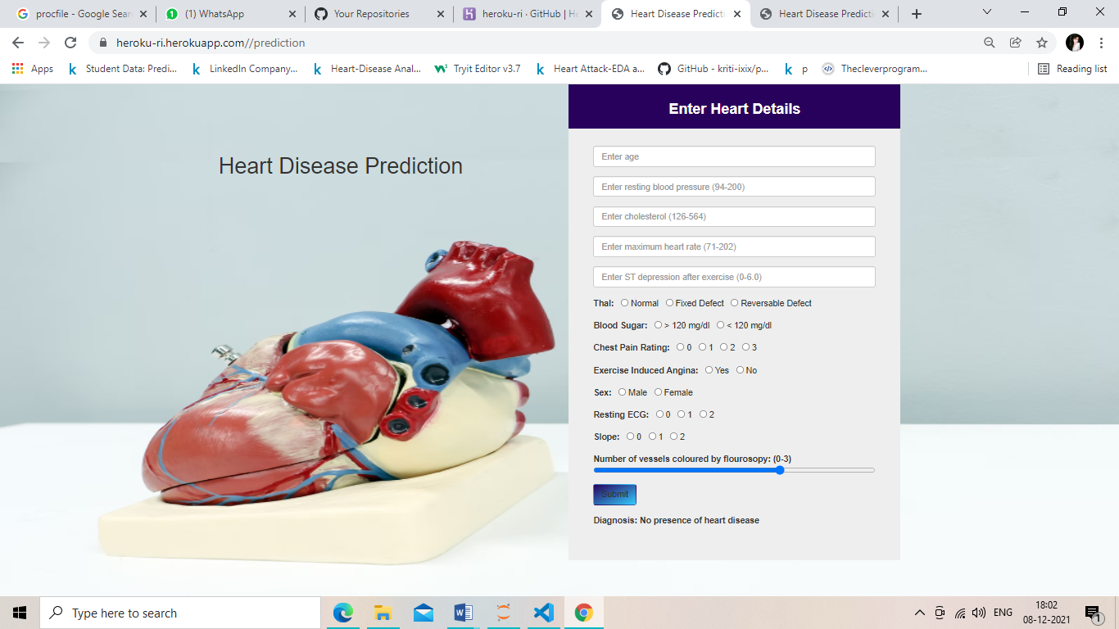

***(****Giving inputs****) (****Prediction****)***

* *If there is presence of heart disease*

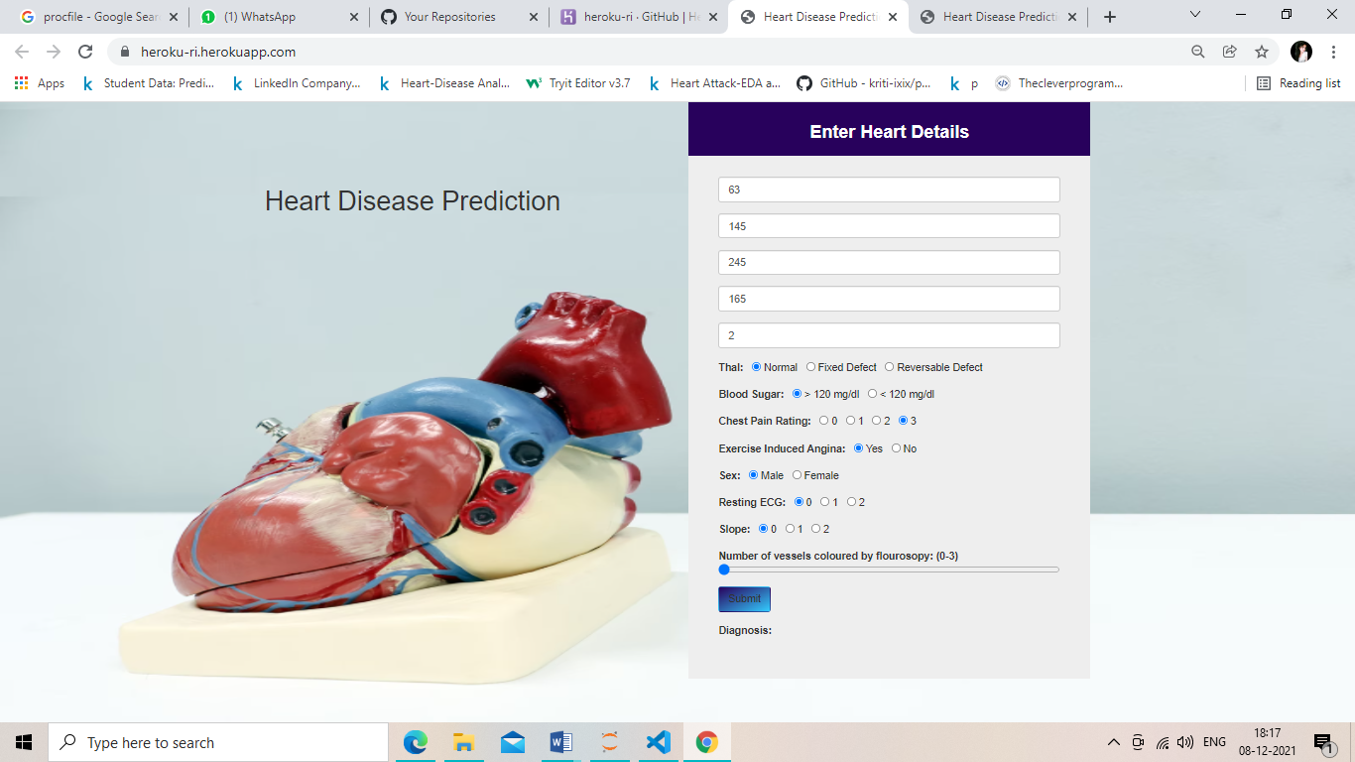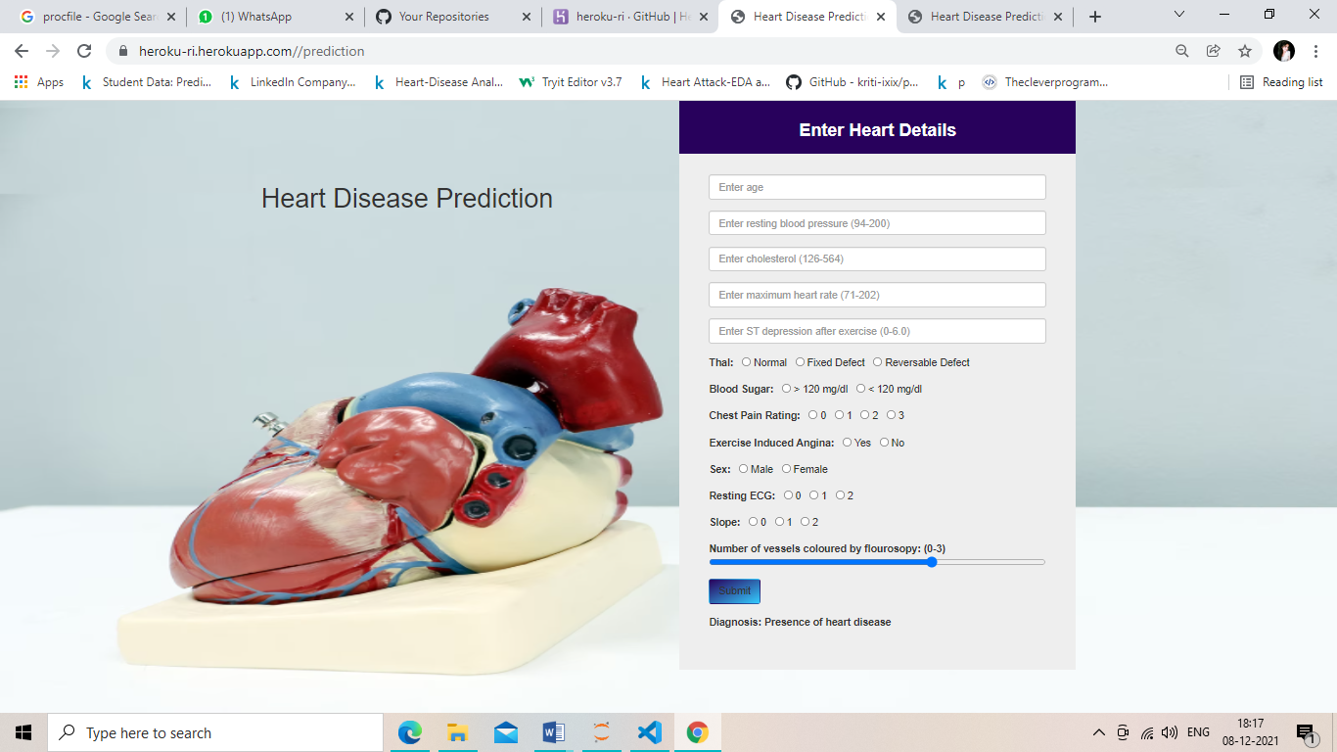

***(****Giving inputs****) (****Prediction****)***

***Predictive Analytics features and benefits***

* Predictive models make use of patterns found in historical and transactional data to identify threats and opportunities.*

* Models depict relationships among many factors to allow evaluation of risk or capability linked with a particular set of circumstances.*

* PA makes available a predictive result (probability) for each (customer, employee, component, organizational unit, healthcare patient, product SKU, vehicle.)*

* Regulate, inform, or influence corporate practices to apply across large numbers of individuals, such as in Marketing, credit risk measurement, fraud uncovering, manufacturing, healthcare, and government operations including law implementation*

***Future scope***

*It has been estimated that data is expected to grow up to 50 times by 2020. Companies have to stay updated with the requirements of huge volumes of data so that they don’t become obsolete. Therefore, experts who are well-versed in advanced analytics are considered to be crucial for organizations to adjust their business models and stay ahead of the competition. To master Data analytics, one can join data analytics training course*

*The scope of data analytics In India includes companies in policing, banking, healthcare, fraud detection, e-commerce, energy, telecommunications, and risk management.*

*JPMorgan, Accenture, Microsoft, Adobe, Flipkart, AIG, Ernst & Young, Wipro, Vodafone & Deloitte are the organizations that had the greatest number of openings for data analysts last year.*

**Conclusion**

*Heart Disease is one of the major concerns for society today.*

*It is difficult to manually determine the odds of getting heart disease based on risk factors. However, machine learning techniques are useful to predict the output from existing data.*